**Describe Operating System**

An Operating System (OS) is an interface between a computer user and computer hardware. An operating system is a software which performs all the basic tasks like file management, memory management, process management, handling input and output, and controlling peripheral devices such as disk drives and printers.

**Types of Operating System**

* Batch OS

It is the first OS of Second generation. In Batch OS the execution works on FIFO strategy. The jobs are known as Batches.

* Real Time OS

Real Time OS uses real time application where processing is done in small times. It is well synchronised and resources are used more efficiently.

It has High CPU utilisation.

Creates several processes which implement real time scheduling.

* Distributive OS

It permits user to use resources located in other users system conveniently.

**Features of Operating System**

* Allows execution of Programs
* Handles I/O Operations
* Error Detection and Handling
* Allocation of Resources
* Memory Management
* Security

**Linux Architecture with Diagram**

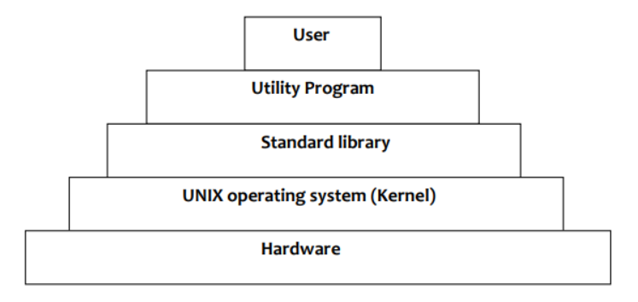

**Hardware**

* Kernel interfaces with Hardware.
* It contains physical components like Memory, Printer, etc.

**Kernel**

* Kernel is the core program of any OS and provides services to the OS like memory management, process management, etc.
* Kernel provides the interface between user and hardware.

**Standard Library**

* It contains set of procedures. This is collection of system level files.

**Utility Program**

* Used to make user programs and make work easier. i.e.- compilers, editors etc.

**User**

* User interacts with the system.

**Shell and Kernel with Example**

**Shell:**

When a user gives his Command for Performing Any Operation, then the Request Will goes to the Shell Parts, The Shell Parts is also called as the Interpreter which translate the Human Program into the Machine Language and then the Request will be transferred to the Kernel. So that Shell is just called as the interpreter of the Commands which Converts the Request of the User into the Machine Language. Some examples of shells are MS-DOS Shell (command.com), csh,ksh, PowerShell, sh, and tcsh.

**Kernel:**

The kernel is the central component of a computer operating systems. The only job performed by the kernel is to the manage the communication between the software and the hardware. A Kernel is at the nucleus of a computer. It makes the communication between the hardware and software possible. While the Kernel is the innermost part of an operating system, a shell is the outermost one. Example the Linux kernel is used numerous operating systems including Linux.

Example the Linux kernel is used numerous operating systems including Linux, FreeBSD, Android and others.

**Linux Commands Screenshots:**

